To configure SNMP version 3 on a Cisco router
To configure SNMP version 3 on a Cisco router, follow these steps. SNMPv3 adds enhanced security features over SNMPv1 and SNMPv2c, including encryption, authentication, and user-based access control. Below are the steps for setting up SNMPv3 with authentication and privacy.
1. Define an SNMPv3 User
Create an SNMPv3 user with authentication and optional privacy (encryption).
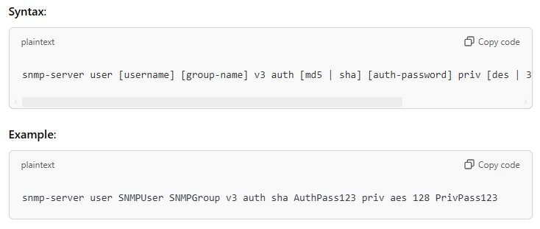
- SNMPUser: Username for the SNMPv3 user.
- SNMPGroup: Group name for SNMP access.
- sha: SHA for authentication (use MD5 if needed).
- AuthPass123: Authentication password.
- aes 128: AES encryption at 128-bit level (DES, 3DES, or AES can be selected).
- PrivPass123: Privacy (encryption) password.

2. Define an SNMP Group
Create an SNMPv3 group to manage access policies for the SNMP user.
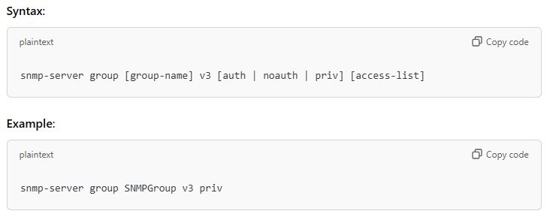
- SNMPGroup: Group name.
- priv: Specifies that both authentication and privacy are required.

3. Configure SNMP Views
Control which MIB objects are accessible through SNMP.
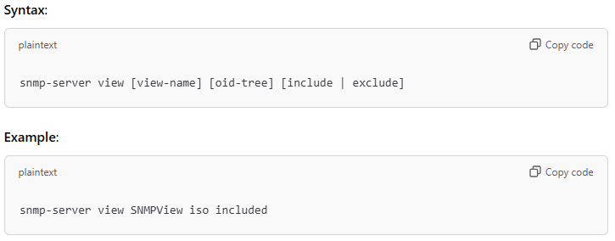
- SNMPView: View name.
- iso: Include the ISO tree of MIB objects.

4. Apply the View to the Group
Associate the view with the SNMP group.
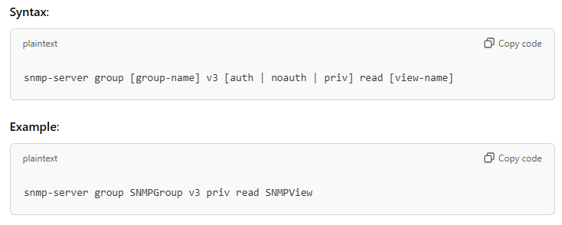
- read SNMPView: Limits access to the objects within the specified SNMP view.

6. Save the Configuration
Ensure to save your changes to prevent them from being lost on a router reload.
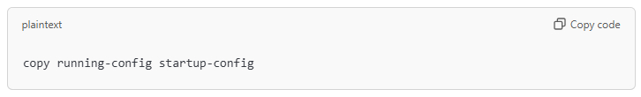
Example Configuration Summary
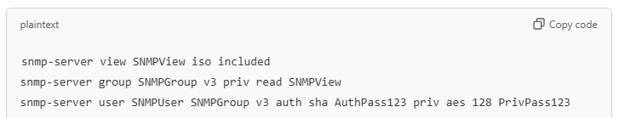
This configuration sets up an SNMPv3 user with both authentication and encryption, limits access to specific MIB objects through views, and enables SNMP traps. Make sure to replace passwords and IP addresses with those specific to your network's requirements.

